**1. What is Boolean? Write down 3 different expression that results a Boolean type (i.e. 5 == 6)**

Boolean is a data type which has 2 values: True or False.  
 E.g:  
 5 > 6  
 x or True == True  
 (8 - 2) <= 4  
   
**2. What is a flow chart? Draw flow chart for the following code snippet: (you can draw on a paper, take a picture of it)**

**if name == “Dinh Quy": print(“Hand some")  
 elif name == “Tuan Anh": even_more_handsome = True  
 else: webbrowser.open(“ https://www.youtube.com/watch?v=04854XqcfCY ”)**   
 A flow chart is a type of diagram that illustrates workflow, process of operations while program is running.

Flow chart: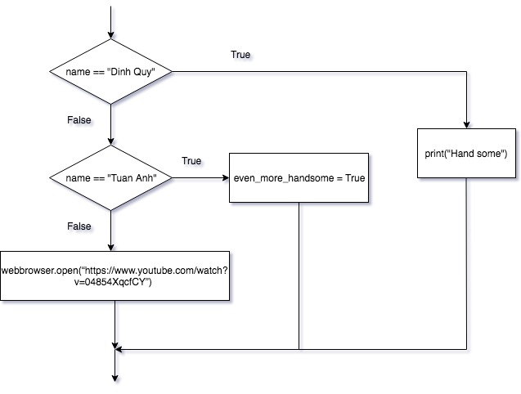  
**3. What is nested conditionals? Write a piece of code that uses nested conditionals**   
 Nested conditional is a conditional that is inside a branch of another conditional.

Piece code that uses nested conditional:  
  
 x = True  
 y = False  
 if x == y:  
 if x == False:  
 print(x,y,”are False”)  
 else:  
 print(x,y,”are True”)  
 else:  
 if x == False:  
 print(x,”is False and”,y,”is True”)  
 else:  
 print(x,”is True and”,y,”is False”)